FULL GUIDE: Build + Secure + Deploy Your AI Troubleshooting Assistant
Below is everything in the correct order.

PHASE 1 — Create Your Project Folder
Create a folder anywhere on your PC:
ai-troubleshooter/
Inside it, create this structure:
ai-troubleshooter/
│
├── main.py
├── auth.py
├── requirements.txt
│
├── templates/
│ ├── login.html
│ └── index.html
│
└── static/
├── style.css
└── script.js
You will paste the code from earlier into these files.

PHASE 2 — Get Your Groq API Key
Groq is free and extremely fast.

Step 1 — Go to Groq
https://console.groq.com

Step 2 — Sign in
Use Google or GitHub.

Step 3 — Go to API Keys
Left sidebar → API Keys

Step 4 — Create a new key
Click Create API Key → Name it → Copy it.

Step 5 — Save it somewhere safe
You will use it later in Render as an environment variable.

PHASE 3 — Install Dependencies (Local Development)
Open a terminal inside your project folder:
pip install -r requirements.txt
Your requirements.txt should contain:
fastapi
uvicorn
groq
jinja2
python-multipart
passlib[bcrypt]
pyjwt

t0 run it under the main folder at command prompt.
python -m venv venv
venv\Scripts\activate

PHASE 4 — Add the Backend Code

main.py
Contains FastAPI backend, login, JWT, and chat endpoint.
(Paste the full code I gave earlier.)

auth.py
Handles password hashing + JWT.
(Paste the full code I gave earlier.)

PHASE 5 — Add the Frontend

templates/login.html
Login page.

templates/index.html

Chat UI.

static/style.css
Modern UI styling.

static/script.js
Chat logic + token handling.
(Paste the full code I gave earlier.)

PHASE 6 — Test Locally
Before deploying, test it on your machine.

Step 1 — Set your Groq key temporarily:
Windows CMD:
set GROQ_API_KEY=your_key_here
Linux/macOS:
export GROQ_API_KEY=your_key_here
Step 2 — Run the server:
uvicorn main:app –reload
Step 3 — Open in browser:
http://127.0.0.1:8000
You should see the login page.

PHASE 7 — Prepare for Deployment
You need a GitHub repository.

Step 1 — Create a GitHub repo

Go to: https://github.com/new Name it: ai-troubleshooter

Step 2 — Upload your project files

PHASE 8 — Deploy to Render (Free Hosting)
Render is the easiest free hosting for FastAPI.

Step 1 — Go to Render
https://render.com

Step 2 — Create an account
Use GitHub login.

Step 3 — Click New → Web Service

Step 4 — Select your GitHub repo
Choose ai-troubleshooter

Step 5 — Configure the service:

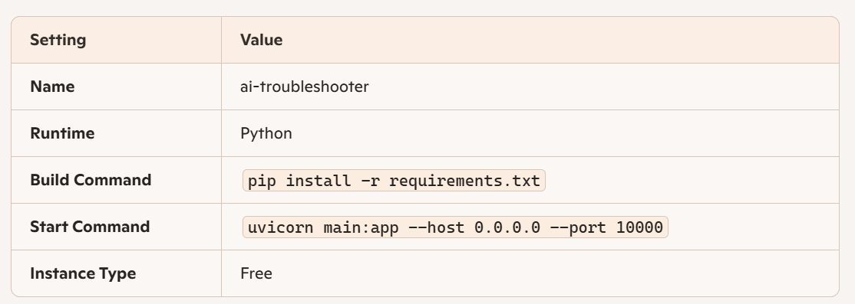

Step 6 — Add Environment Variables
Click Environment → Add Variable

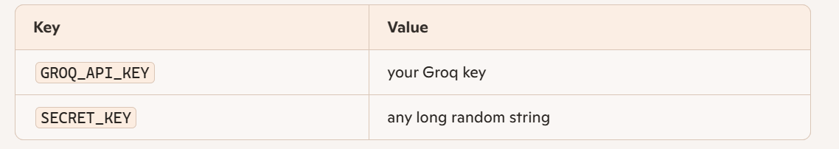
Example SECRET_KEY:
fj39fj3f9j3f9j3f9j3f9j3f9j3f9j3f9j3f9j3f9

Step 7 — Deploy
Render will build your app and give you a public URL, like:
https://ai-troubleshooter.onrender.com

PHASE 9 — Test Your Public App
- Open your Render URL
- Login using one of the users in auth.py:
Example:
username: maurice
password: password123
• You will be redirected to /chat
• Start using your AI Troubleshooting Assistant online

PHASE 10 — Share With Coworkers
Give them the URL
https://ai-troubleshooter.onrender.com
And the login credentials you want them to use.
users_db = {
"maurice": pwd_context.hash("password123"),
"coworker1": pwd_context.hash("mypassword"),
"coworker2": pwd_context.hash("secret123"),
}
Push to GitHub → Render redeploys automatically.

Debug level
uvicorn main:app --reload --log-level debug

